First of all I would like to thank all of the parents who were able to make it to our meeting last night. If you were unable to make it, please let me know if you have any questions about the information that is in the handbook that came home last week.

At the meeting we also talked about the Acellerated Reading program. If you have any questions about this program or how it works please feel free to email me at any time and I will try my best to answer your questions.

APPLESAUSE TASTING

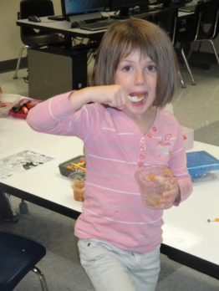 **We made our own version of applesauce on Tuesday with all the apples that were brought in last week. The sauce turned out great and our room smelled delicious all day long! All of the kids tried the sauce and many of them liked it! A few even asked for seconds! Be sure to check with your student and see what they thought of it!**

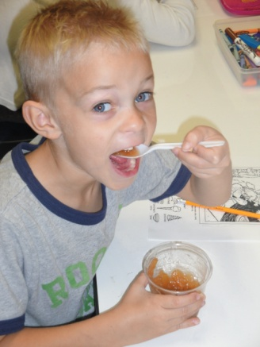 **If you’d like to try making it a home it is really easy. We cut up all our apples and put them in a crockpot with about a cup of brown sugar and ½ to 1 cup of water. Cook it on low for about 4 hours. Be sure to let it cook some before you taste it- this is the hardest part because it smells so good!**

**Spelling List**

C:\Users\taolson\AppData\Local\Microsoft\Windows\Temporary Internet Files\Content.IE5\CT93IAZ4\MC900048276[1].wmfStarting this week we will be sending home spelling words each Friday on the back of the newsletter. We will be testing on these words on Wednesday and again on Friday. I will take the best of the two scores for the final grade. We are starting with just six words but the list will gradually grow as we get into our reading curriculum.

There is a great website available to help your student work with our spelling words each week. The site is: [www.spellingcity.com](http://www.spellingcity.com) Right now the lists are all under Mrs. Justesen. If you go to the sight then click on find a list and type in her name our list will show up. There are many great word games that you can play on this sight. A favorite so far in our room is “Hang Mouse” with color words. Hit the web and give it a try!

FALL FUN

Starting next week we will be focusing on ‘Fall’ for our theme. Please keep your eye out for fall themed papers and projects to be coming home.

Upcoming Events:

Library day is Wednesday

Public Library visit Thursday

Homecoming week is Oct 3-10